

COLLAGE OF ENGINEERING

DEPARTMENT OF ELECTRICAL

AND

COMPUTER ENGINEERING

STREAM OF COMPUTER

GROUP PROJECT

COURSE TITLE: DATA COMMUNICATION & COMPUTER NETWORK

COURSE CODE: ECEG4291

GROUP MEMBERS

1. DANIEL MASRESHA

2. AMANUEL GETACHEW ZEWDIE

3. ELIAS GEBREAMANUEL

4. RUHAMA ABRAHAM ASHA

5. YEABTSEGA ASAYEHEGN

SUBMITTIED TO AGA BAYOU

SUBMISSION DATE 31/05/22

Contents

Introduction 3

MPLS Meaning 4

MPLS Network 4

Figure: Basic MPLS Network 4

MPLS Packet lable format 5

The MPLS architecture 5

MPLS pros 7

MPLS Cons 8

■ Internet traffic cannot be routed locally 8

■ Single point of failure 8

Operation of Multiprotocol Label Switching 8

Conclusion 10

# Introduction

Before we dive into MPLS, let’s explain how data travels through the internet. When you send an email, connect to VoIP or video conferencing, that data packet or IP packet is sent from one internet router to its destination. The internet router must decide for each IP packet/data packet how it’s sent to the destination IP. Each packet requires a decision, which the router uses complex routing tables to determine. Every path the packet arrives at requires another forwarding decision until it arrives at its destination. This process can result in poor performance for users, the applications they are using and impact the network across an organization. MPLS provides an alternative for organizations to increase network performance and improve user experience

# MPLS Meaning

Multi-protocol Label Switching, or MPLS, is a networking technology that routes traffic using the shortest path based on “labels,” rather than network addresses, to handle forwarding over private wide area networks. As a scalable and protocol-independent solution, MPLS assigns labels to each data packet, controlling the path the packet follows. MPLS greatly improves the speed of traffic, so users don’t experience downtime when connected to the network.

# MPLS Network

An MPLS network is Layer 2.5, meaning it falls between Layer 2 (Data Link) and Layer 3 (Network) of the OSI seven-layer hierarchy. Layer 2, or the Data Link Layer, carries IP packets over simple LANs or point-to-point WANs. Layer 3, or the Network Layer, uses internet-wide addressing and routing using IP protocols. MPLS sits in between these two layers, with additional features for data transport across the network

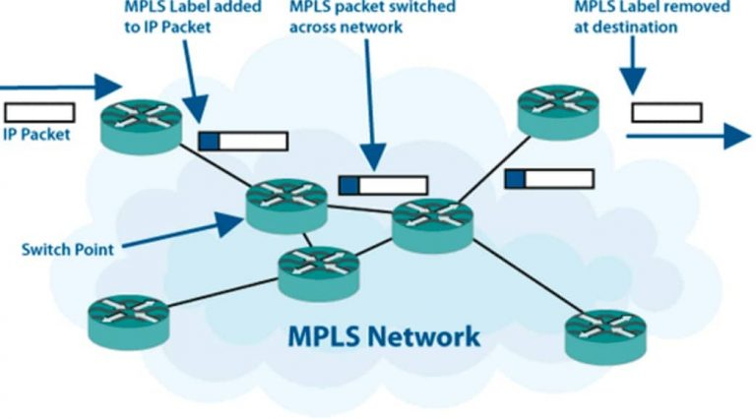

## Figure: Basic MPLS Network

## 

## MPLS Packet lable format

|  |  |  |  |
| --- | --- | --- | --- |
| Label (20 bits) | Class of Service (CoS) (3 bits) | Stack bit (S) | TTL (8 bits) |

|  |  |  |  |
| --- | --- | --- | --- |
| L2 Header | MPLS Header | L3 Header | L3 Data |

|  |  |  |  |  |
| --- | --- | --- | --- | --- |
| L2 Header | MPLS Header | MPLS Header | L3 Header | L3 Data |

# The MPLS architecture

The MPLS architecture describes the mechanisms to perform label switching, which combines the benefits of packet forwarding based on Layer 2 switching with the benefits of Layer 3 routing. Similar to Layer 2 networks (for example, Frame Relay or ATM), MPLS assigns labels to packets for transport across packet- or cell-based networks. The forwarding mechanism throughout the network is label swapping, in which units of data (for example, a packet or a cell) carry a short, fixed-length label that tells switching nodes along the packets path how to process and forward the data.

The significant difference between MPLS and traditional WAN technologies is the way labels are assigned and the capability to carry a stack of labels attached to a packet. The concept of a label stack enables new applications, such as Traffic Engineering, Virtual Private Networks, fast rerouting around link and node failures, and so on.

Packet forwarding in MPLS is in stark contrast to today's connectionless network environment, where each packet is analyzed on a hop-by-hop basis, its layer 3 header is checked, and an independent forwarding decision is made based on the information extracted from a network layer routing algorithm.

The architecture is split into two separate components: the forwarding component (also called the data plane) and the control component (also called the control plane). The forwarding component uses a label-forwarding database maintained by a label switch to perform the forwarding of data packets based on labels carried by packets. The control component is responsible for creating and maintaining label-forwarding information (referred to as bindings) among a group of interconnected label switches. Figure 1-3 shows the basic architecture of an MPLS node performing IP routing.

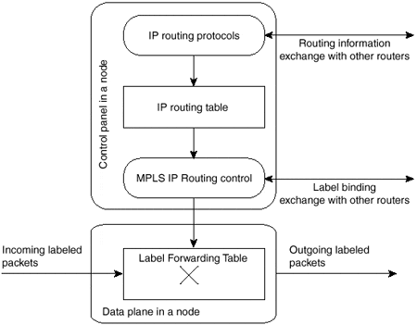

##### **Figure: Basic Architecture of an MPLS Node Performing IP Routing**

Every MPLS node must run one or more IP routing protocols (or rely on static routing) to exchange IP routing information with other MPLS nodes in the network. In this sense, every MPLS node (including ATM switches) is an IP router on the control plane.

Similar to traditional routers, the IP routing protocols populate the IP routing table. In traditional IP routers, the IP routing table is used to build the IP forwarding cache (fast switching cache in Cisco IOS) or the IP forwarding table (Forwarding Information Base [FIB] in Cisco IOS) used by Cisco Express Forwarding (CEF).

# MPLS pros

* Traffic Engineering - the ability to set the path traffic will take through the network, and the ability to set performance characteristics for a class of traffic
* The benefits of MPLS are scalability, performance, better bandwidth utilization, reduced network congestion and a better end-user experience.
* MPLS itself does not provide encryption, but it is a virtual private network VPN and, as such, is partitioned off from the public Internet. Therefore, MPLS is considered a secure transport mode. And it is not vulnerable to denial-of-service attacks, which might impact pure-IP-based networks.
* VPNs - using MPLS, service providers can create IP tunnels throughout their network, without the need for encryption or end-user applications
* Layer 2 Transport - New standards being defined by the IETF's PWE3 and PPVPN working groups allow service providers to carry Layer 2 services including Ethernet, Frame Relay and ATM over an IP/MPLS core
* Elimination of Multiple Layers - Typically most carrier networks employ an overlay model where SONET/SDH is deployed at Layer 1, ATM is used at Layer 2 and IP is used at Layer 3.  Using MPLS, carriers can migrate many of the functions of the SONET/SDH and ATM control plane to Layer 3, thereby simplifying network management and network complexity.  Eventually, carrier networks may be able to migrate away from SONET/SDH and ATM all-together, which means elimination of ATM's inherent "cell-tax" in carrying IP traffic.

# MPLS Cons

### Internet traffic cannot be routed locally

Since MPLS transport doesn’t have layer 3 routing capabilities, the packets in and out of the branch offices need to go through the MPLS gateway at the service provider core. This means any type of traffic, including web surfing or traffic destined to public clouds, will go through the expensive MPLS circuits just to connect to the Internet.

* **MPLS cost is high**

MPLS transport is expensive. Especially when compared to widely available broadband Internet access lines such as DSL, cable and fiber. Per-bit cost of MPLS can unnecessarily consume a significant portion of the IT budget. To overcome MPLS bandwidth bottlenecks IT managers are usually presented with expensive MPLS upgrade options that are not practical.

### Single point of failure

MPLS usually is advertised by carriers to have higher uptime, however they still go down when the carrier has a technical problem. Since MPLS is primarily based on a single service provider and single transport, it can be crippled by a single point of failure.

# Operation of Multiprotocol Label Switching

Label Switched Paths (LSPs) are predetermined, unidirectional paths between pairs of routers across an MPLS network.

1. When a packet enters the network through a Label Edge Router (also known as an “ingress node”), it is assigned to a Forwarding Equivalence Class (FEC), depending on the type of data and its intended destination. FECs are used to identify packets with similar or identical characteristics.
2. Based on the FEC, the ingress node will apply a label to the packet and encapsulate it inside an LSP.
3. As the packet moves through the network’s “transit nodes” (also known as Label Switch Routers), those routers continue to direct the data by the instructions in the packet label. These in-between stops are based on the packet label, not additional IP lookups.
4. At the “egress node,” or final router at the end of the LSP, the label is removed and the packet is delivered via normal IP routing.

A label stack is made up of at least four parts:

**Label value**: holds the information for routers to determine where the packet should go next

**Traffic class field**: sets Quality of Service priority and Explicit Congestion Notification

**Bottom of stack flag**: indicates the last label in the stack

**Time-to-live (TTL)** **field**: limits the lifespan of the data, or how many hops it can make before it’s discarded

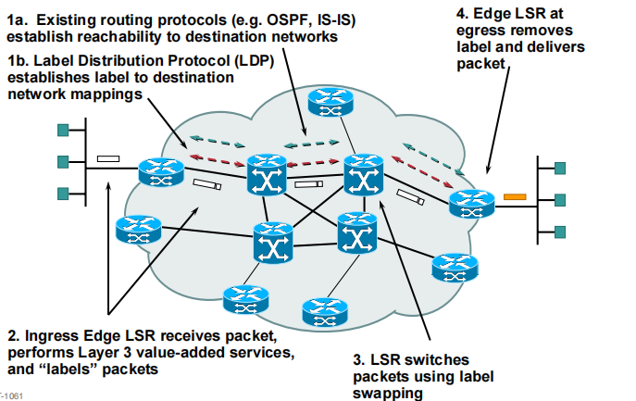 **Figure: Operation of MPLS**

# Conclusion

Multiprotocol Label Switching (MPLS) combines the intelligence of routing with the performance of switching and provides considerable benefits to networks with a pure IP architecture as well as those with IP and ATM or a mix of other Layer 2 technologies. In this report describe the need for implementing MPLS technology to overcome some of the limitations involved in pure IP based forwarding. The innovative label based system simplifies IP based traffic routing from source to destination without affecting and manipulating the IP packets, thus highlighting the security aspect of MPLS networks.

In this report it provide overall ideas about MPLS network meaning , advantages that we get by using MPLS on our network, architecture of MPLS, some topologies widely used.